

(Department of Computer Engineering)

MINI PROJECT

DATABASE MANAGEMENT SYSTEM

Under the guidance of:

Mr.Deepak .S. Khanc

Group members:

Manali Joshi Roll No : 22

Nayan Karpe Roll No : 24

Vedprakash Maurya Roll No : 35

**Problem Definition:**

Front-end Back-end application.

**Technical Specifications:**

Hardware: PC specifications- Windows 10

Software: Text editor, Xampp

**Introduction :**

With the advancement in technology, Web is becoming very much more important in our daily lives, in which virtually everything we do nowadays involves the use of web. More so, the application of Web is not limited to computers but it is opened to different kinds of intelligent digital devices, for example the mobile ones. Also, the architecture of the Web is the Client-Server model, in which as a result the communication between the client and server is the first thing we should be concerned about [1]. Client/server system has increasingly minimized application development time by dividing functions of sharing information into both the client and server. The client is the requester while the server is the provider of service. In most client-server environment, the data processing is handled by the server, and the results are returned to the clients, which is made to speed up the rate of performance [2].For example, in a workstation, a printer can be attached to a computer (representing the clients) while other computers sharing from it are the server.

What Is Client-Server System In the computing world today, client-server system has become so popular because it is being used virtually every day for different applications. Some of the standardized protocols that client and servers use to communicate with themselves include: File Transfer Protocol (FTP), Simple Mail Transfer Protocol (SMTP) and Hypertext Transfer Protocol (HTTP). Thus, Client-server system can be define as a software architecture made up of both the client and server, whereby the clients always send requests while the server responds to the requests sent[3]. Client-server provides an inter-process communication because it involves the exchange of data from both the client and server whereby each of them performs different functions

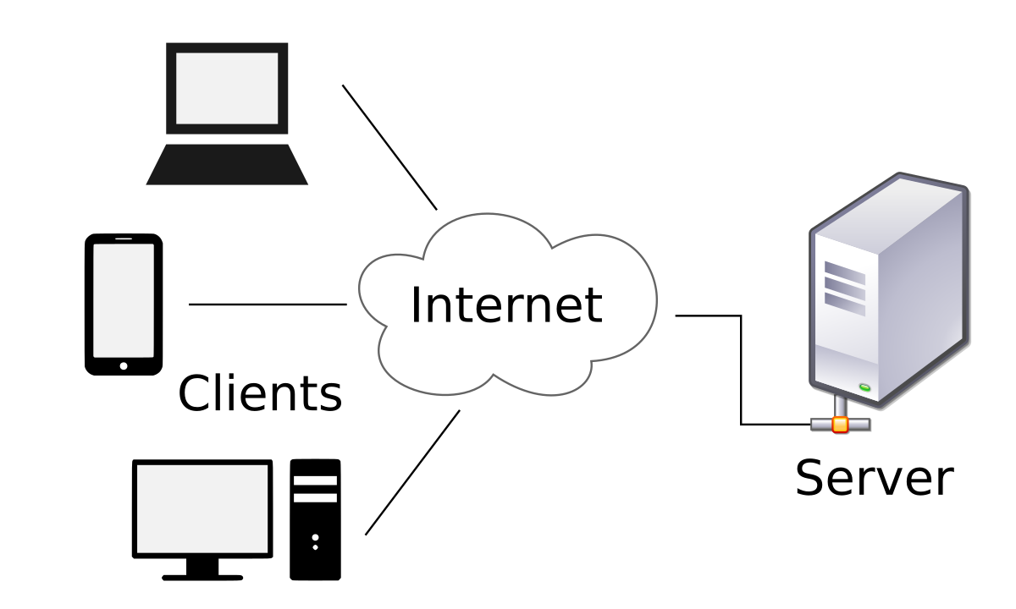

**Interprocess communication among client and server :**

1. Benefits of client server model

• It splits the processing of application across multiple machines. Client process Server Database process IPC Database Client 1 Client 2 Client 3 Server Client-Server Model

• It allows easier sharing of resources from client to servers.

• It reduces data replication by storing data on each server instead of client.

B. Example of applications using client-server system –

**File transfer:** This is the transmission of files between the client and server. It also allows storing of files on the server. Files such as movies, images, music can be stored.

**Mail transfer:** This is the transfer of messages such as the email using the Mail Transfer Protocol (MTP).

**Hypertext Transfer Protocol (HTTP):** Is the transferring of multimedia files such as images, text between the client and server. HTTP is use to improve communication between the client and server, by serving as a request-response protocol. Figure 5: HTTP III. Client-Server Systems Architecture

Client-server architecture is usually made up of the; application server, database server and PC. The two main architectures are the 2-tier and 3-tier architecture.

**• 2-tier client-server system architecture:** This is an architecture which involves only the Database server and a client PC. In 2-tier architecture, the users will run applications on their PC (Client), which connects through a network to the server. The client application runs both the coding and business logic, and then displays output to the user. It is also called thick client. It is considered when the client has access to the database directly without involving any intermediary. -It is also used to perform application logic whereby the application code will be assigned to each of the client in the workstation. 2-tier client –server architecture. Client program Database request Client program Database request Database management.

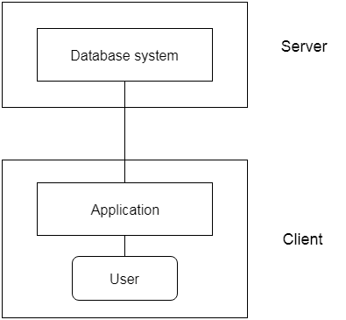

**Description:**

XAMPP is an open source software developed by [Apache friends](https://www.apachefriends.org/download.html). XAMPP software packagecontains Apache distributions for Apache server, MariaDB, PHP, and Perl. And it is basically a local host or a local server. This local server works on your own desktop or laptop computer. The use of XAMPP is to test the clients or your website before uploading it to the remote web server. This XAMPP server software gives you the suitable environment for testing MYSQL, PHP, Apache and Perl projects on the local computer.

The full form of XAMPP is X stands for Cross-platform, (A) Apache server, (M) MariaDB, (P) PHP and (P) Perl. The Cross-platform usually means that it can run on any computer with any operating system.

Next MariaDB is the most famous database server and it is developed by MYSQL team. PHP usually provides a space for web development. PHP is a server-side scripting language. And the last Perl is a programming language and is used to develop a web application.

The XAMPP installation process is very simple and fast. Once XAMPP is installed on your local computer it acts as a local server or localhost. You can test the websites before uploading it to the remote web server. This XAMPP server software gives you a suitable environment for testing MYSQL, PHP, Apache and Perl applications on a local computer.

### What are the Main Tools of XAMPP  and its definition?

XAMPP contains tools such as Apache, MYSQL, PHP, and Perl. We will see these tools.

[**Apache**](https://httpd.apache.org/)

Apache server is an open source free software which is initially developed by a group of software developers and now it is maintained by Apache software foundation. Apache HTTP is a remote server(computer) if someone request files, images or documents using their browser they will serve those files to clients using HTTP servers. Mainly hosting companies use this application to create a VPS server and shared hosting for their clients.

[**MYSQL**](https://www.mysql.com/)

MYSQL is an open source software. It is actually a relational database management system(RDBMS). This SQL stands for Structured Query Language. It is the most popular and best RDBMS used for developing a variety of web-based software applications. With the help of MYSQL, it is possible to organize the information, manage, retrieve and update the data whenever you wish to do.

[**PHP**](http://php.net/)

The full form of PHP is Hypertext Preprocessor. It is a server-side scripting language that helps you to create dynamic websites. This language is mainly used to build web-based software applications. It is an open source software and works fine with MYSQL. What actually happens is, the PHP code will be executed on the server and at the browser side its HTML code will be displayed.

[**Perl**](https://www.perl.org/)

Perl is usually said to be the general purpose programming language. This Perl language is interpreted and highly dynamic. Actually, this language is used for web development, GUI development, system administration, etc. Perl is capable of working with HTML, XML and other markup languages.

In the latest version of XAMPP, there are additional tools such as Mail server Mercury, OpenSSL, phpMyAdmin, etc. With the above tools, you can create a full-fledged desktop server.

Conclusion: